**500W Starlight Class_20X Network Movement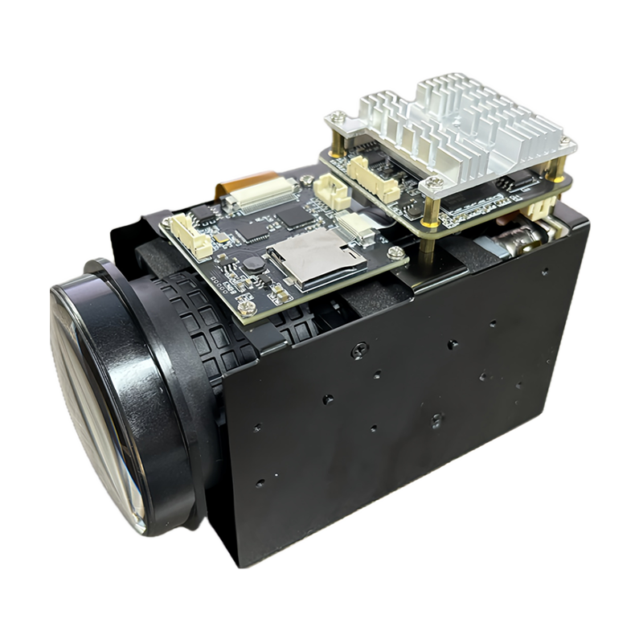（****500W星光级_20X网络机芯）**

**Product characteristics：**

* **Video resolution：2488*2048/60fps ；Video encoding:H.265/H.264/MJPEG**
* **Excellent autofocus algorithm**
* **Integrated neural network acceleration engine, computing power up to 2.5Tops INT8**
* **Supports Neon accelerate and integrates FPU processing units**
* **Dual ARM Cortex A55@1.2GHz processor, 32KB I-Cache, 32KB D-Cache ,256KB L3 cache**
* **Support AI super noise reduction, 3D noise reduction, 2D noise reduction, image edge enhancement, defogging, dynamic contrast enhancement, etc.**
* **Support to remove fixed pattern noise (FPN)**
* **Supports OSD character overlay and BMP image overlay, with adjustable overlay position**
* **Supports ONVIF protocol and national standard GB/T28181 protocol;**
* **Adopting H.264 H.265 video encoding, users can choose the stream and adjust the resolution, frame rate, and video quality;**
* **Support motion detection alarm and client alarm;**
* **Support bad pixel correction and lens shadow correction;**
* **Supports motion detection/occlusion of images, with the ability to set up 4 occlusion areas and 4 detection areas;**
* **Support network time synchronization and RTC power-off timing function;**
* **Support remote real-time monitoring, network user management, and network time synchronization;**

**Datasheet:**

|  |  |  |  |  |
| --- | --- | --- | --- | --- |
| **Order Model** | | **M568H19D5_S_L21_20X** | | **M568H19D5_E_L21_20X** |
| **System** | | | | |
| **CPU Model** | | **HI3519DV500 Dual ARM Cortex A55@1000MHz** | | |
| **CPU ability** | | **2.5 Tops** | | |
| **Flash** | | **256Mbit SPI Nor Flash** | | **8GB eMMC** |
| **DDR** | | **8Gbit DDR4 (2x 4Gbit)** | | **8Gbit DDR4 (2 X 4Gbit)** |
| **Image** | |  | |  |
| **Sensor Board** | | | **SONY IMX568,1/1.8’ CMOS Sensor** | | |
| **T-WDR** | | | **>80db** | | |
| **Video Resolution** | | | **2488(H)x2048(V)** | | |
| **Lens** | | | **6.7~134.5mm±5%** | | |
| **Aperture** | | | **F1.5(Wide)~F3.4(Tele)±5%** | | |
| **Field angle** | | |  | **Wide** | **Tele** |
| **D** | **70°** | **3.76°** |
| **H** | **59.8°** | **3.0°** |
| **V** | **44.4°** | **2.24°** |
| **S/N Ratio** | | | **≥52db** | | |
| **3D Noise** | | | **Support** | | |
| **Optical zoom** | | | **20X** | | |
| **ICR Switch** | | | **Auto ICR full color switch to B/W** | | |
| **Wide Dynamic** | | | **Support** | | |
| **BLC** | | | **Support** | | |
| **white balance** | | | **Automatic/Indoor/Outdoor** | | |
| **Focus control** | | | **Auto /Manual** | | |
| **Electronic shutter** | | | **1/25—1/10000s** | | |
| **Min Illumination** | | | **Color 0.001 Lux@(F1.6,AGC ON)** | | |
| **Audio video encoding** | | | | | |
| **Video Encoding** | | | **H.265/H.264/MJPEG** | | |
| **Video Frame** | | **Main stream** | **2488*2048 2048*1520 1920*1080 1-60fps** | | |
| **Sub stream** | **1280*720 704*576 640*480 352*288 1-60fps** | | |
| **Video Bit rate** | | | **32Kbps~80Mbps continuously adjustable, supporting CBR/VBR** | | |
| **Subtitle Overlay** | | | **Support adjustable stacking position of channel name, date and time** | | |
| **Audio Encoding** | | | **G.711A / G.711U** | | |
| **Audio/Intercom Input** | | | **2ch audio in(1ch Line In &1ch MIC In)** | | |
| **Audio Output** | | | **1ch audio out** | | |
| **Storage Interface** | | | **Support SD/TF card storage,max 1T storage(need add one board)** | | |
| **Ethernet Interface** | | | **10/100M network adaptive, RJ45 adapter** | | |
| **Data Transmission and Storage** | | | | | |
| **Data Storage** | | | **Video and image files** | | |
| **Storage Mechanism** | | | **Manual, automatic (cyclic, timed, alarm switch, motion detection, occlusion detection)** | | |
| **Alarm Data Transmission** | | | **Email, browser, management software** | | |
| **Protocol** | | | **TCP/IP、UDP、RTP、RTSP、RTMP、RTCP、HTTP、DNS、DDNS、DHCP、NTP、PPPOE、SMTP、UPNP** | | |
| **Wireless Protocol Support (-W)** | | | **802.11b/g/n, Support WEP, WPA, WPA2 encryption protocols** | | |
| **Client Browsing** | | | **Support embedded Web Server, support concurrent access by 8 users (MAX)** | | |
| **Access Protocol** | | | **ONVIF, GBT28181 B protocol** | | |
| **General Info** | | | | | |
| **Power Supply** | | | **DC12V power supply/POE power supply (need add POE expansion board)** | | |
| **working environment** | | | **Temperature:-20°~+70° ; humidity:0% -90%** | | |

**Pin definition :**

