**12MP Ultra HD Super Starlight IP Module**

**Product Feature:**

* Video resolution：4000*3000/30fps ;
* Video Encoding:H.265/H.264/MJPEG
* Integrated neural network acceleration engine, computing power up to 2.5Tops INT8 (support INT4/FP16);
* Quad-core ARM Cortex A55@1.2GHz processor, 32KB I-Cache, 32KB D-Cache /512KB L3 cache, supports Neon acceleration, integrated FPU processing unit;
* Built--in 32bit MCU@500MHz，32KB I-Cache，32KB D-Cache /64KB TCM；
* Built-in dual core vision Q6 DSP，32K I-Cache /32K D-Cache /32K IRAM/320K DRAM；
* support MJPEG/H264/YUV2 encoding, support 4K/5MP/2K/1080P/720P/D1/VGA resolutions (optional function);
* Support HDMI output ( mini HDMI2.0), HDMI output max resolution is 4K@60 (optional function);
* Default dual stream (three streams customized)
* Support AI super noise reduction, 3D noise reduction, 2D noise reduction, image edge enhancement, defogging, dynamic contrast enhancement, etc.
* Support to remove fixed pattern noise (FPN);
* Support automatic restart function after power failure/accidental failure;
* POE/WIFI are optional function；

**Datasheet：**

|  |  |  |  |
| --- | --- | --- | --- |
| Order Model | | | M577S927_L21_EN |
| System | | | |
| CPU | | | SS927 4ARM Cortex A55@1.4GHz |
| Algorithm | | | 2 .5 Tops INT8 |
| Flash | | | 8GB EMMC |
| DDR | | | 2GB LPDDR4X (2x1GB) |
| Image | | | |
| Sensor | | | SONY IMX577，1/2.3″ Progressive Scan CMOS Sensor |
| Wide Dynamic Range | | | 100dB |
| Video Resolution | | | 8MP/4000*3000 |
| Video Encoding | | | H.265/H.264/MJPEG |
| Video Resolution | | Main stream | 4000*3000 3840*2160 2592*1944 2048*1536 1-30fps |
| Sub stream | 1920*1080 1280*720 704*576 352*288 1-30fps |
| Video Bit rate | | | 32kbps~60Mbps，CBR/VBR adjustable |
| S/N Ratio | | | ≥50dB |
| Min Illumination | | | Color 0.02 Lux@F1.2 |
| Audio | | | |
| Audio I/O | | | 1CH Line In Or 1CH MIC In,1CH Line Out. Support two-way voice intercom |
| Audio Encoding | | | G.711A、G.711U |
| Function | | | |
| AE | | | Support |
| AGC | | | Support |
| AWB | | | Support |
| Noise Reduction | | | Support 2D noise reduction/3D noise reduction/ AI super noise reduction |
| Private Masking | | | Up to set 4 Privacy mask area |
| Interesting Area Code | | | Support |
| Video Record Off Network | | | Support |
| Motion Detection | | | Support 4 detection area |
| Video Adjust | | | Adjust image contrast, brightness, saturation, sharpness and image mirroring, flipping, fog penetration, strong light suppression, backlight compensation, noise reduction level, digital wide dynamic, etc. |
| Remote Management | | | System setting/Video stream management/Account management/Network management |
| Alarm Detection | | | E-mail alarm,PC VMS alarm,Motion detection alarm |
| Hardware Interface | | | Reset(restore factory setting) |
| 2 Group TTL Serial Port ,communication with device or control PTZ Pan（One group can set to RS485 serial port） |
| 1Ch alarm in ,1CH alarm out（Multi channel alarm to be customized） |
| Support SD/TF storage，max support 512G （optional function） |
| Support MJPEG/H264/YUV2 encoding .support 4K /5MP/2K/1080P/720P/D1/VGA resolution（optional function） |
| HDMI 2.0 video output 4K@60（optional function） |
| OSD Overlay | | | OSD place ,color ,words can be setting |
| Network | | | |
| Ethernet Interface | | | RJ45 10M/100M/1000M |
| Video Stream | | | Dual stream |
| Network Protocol | | | TCP/IP、UDP、RTP、RTSP、RTCP、RTMP、HTTP、HTTPS、802.1X、DNS、DDNS、DHCP、NTP、PPPOE、SMTP、UPNP; |
| ONVIF | | | ONVIF Profile S |
| CGI | | | Support |
| General | | | |
| Working Temperature | | | -30°~+70° |
| Working Humidity | | | 10%~90% |
| Power Adaptor | | | DC12V |
| Module Size | | | |
| PCB Size | CPU Board | | Board size:56mm*56mm，Screw hole distance:34mm*34mm； |
| Sensor Board | | Board size :38*38mm, Screw hole distance:34mm*34mm,Lens holder distance:22mm |

;vv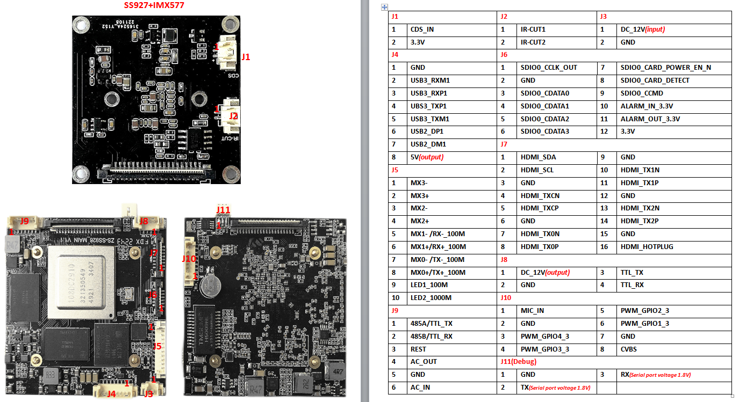

T