# 5MP IMX675 Starlight AI IP Camera Module

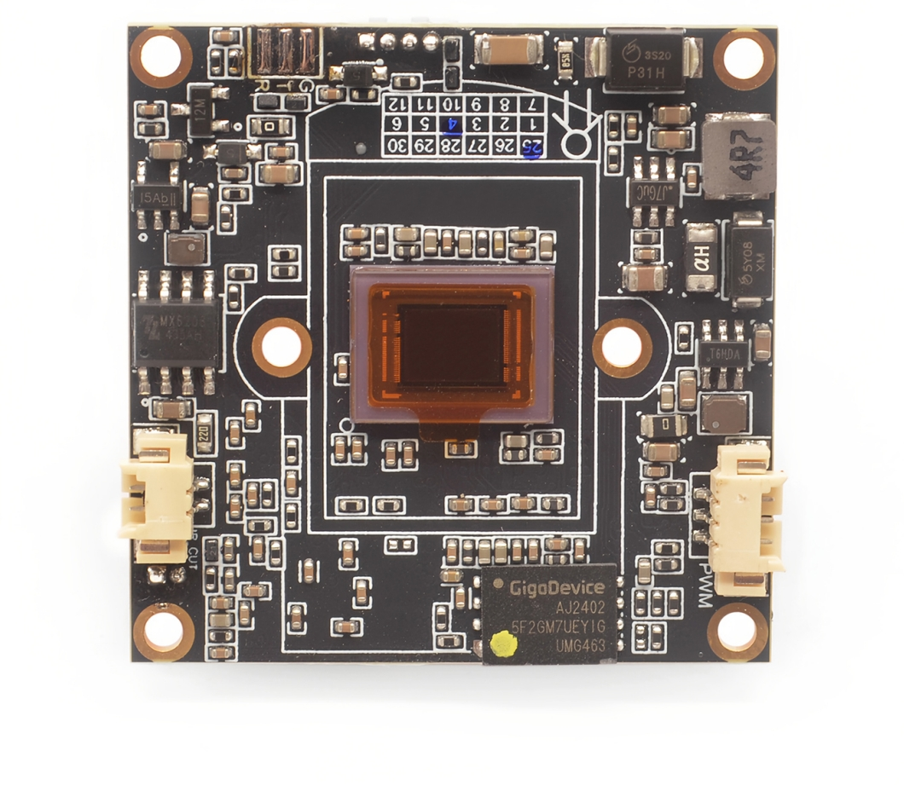

**Product features**

&H.265/H.264/MJPEG

&Video resolution：2592*1944/25fps

&Motor Lens: 2.8-12mm/6-22mm/5-50mm（optional）

&True WDR 120DB and AI denoise function

&Camera module built-in RTC battery

&support 2ch audio in&1ch audio out,1ch alarm in,1ch reset.

&TF card storage & alarm out &POE&WIFI are optional

&Support ONVIF Profile S

|  |  |  |  |
| --- | --- | --- | --- |
| Order Model: M675H16V60-L11 | | | |
| CPU Chips | | | HI3516CV610-00S |
| DDR | | | 4Gbit DDR3 |
| Flash | | | 2Gbit SPI NAND Flash |
| Module Size: | | | |
| One board | | PCB size :38mm*38mm，  Lens holder size:34mm*34mm | |
| Image | | | |
| CMOS Sensor | | | SONY IMX675，1/2.8″Progressive Scan CMOS |
| Motor lens | | | 2.8-12mm/6-22mm/5-50mm（(optional） |
| Video resolution | | | 2592*1944/25fps |
| Video coding | | | H.265/H.264/MJPEG |
| Video | Main stream | | 2592*1944 2560*1440 1920*1080 1-30fps |
| Sub stream | | 1920*1080 1280*720 704*576 640*480 352*288 1-30fps |
| Video Bit rate | | | 32kbps~80Mbps，CBR/VBR |
| S/N Ratio | | | ≥54dB |
| Min Illumination | | | Color 0.005Lux@F1.2 |
| Audio | | | |
| Audio Interface | | | 1ch audio in(1ch Line In &1ch MIC In)  1ch Line out,support voice intercom |
| Audio compression | | | G.711A、G.711U |
| Image | | | |
| AE | | | Support |
| AGC | | | Support |
| AWB | | | Support |
| 3D | | | Support |
| Privacy Mask | | | Up to set 4 Privacy mask area |
| ROI | | | Support |
| Off network record video | | | Support |
| Motion detect | | | Up to set 4 motion detect area |
| Day&Night Switch | | | Built-in intelligent algorithm to auto control IR CUT switch,color and white&night auto switch |
| Video adjust | | | Adjustable image contrast, brightness, saturation, sharpness and image mirroring, flipping, fog penetration, strong light suppression, backlight compensation, noise reduction level, digital wide dynamic, etc. |
| Corridor mode | | | support |
| Remote manager | | | System setting/Video stream management/Account management/Network management |
| Alarm Detect | | | E-mail alarm,PC client alarm,Motion detect alarm |
| Function Interface | | | 1ch Reset |
| 2group TTL serial port,use to connect communicate device or PTZ control(1 ch can be choose RS485 port) |
| 1ch alarm in(standard),1ch alarm out（optional,need add one board） |
| SD/TF card storage，max 128G（optional,need add one board） |
| 1ch USB,support UVC protocol video output  support MJPEG/H264 Coding,5MP/2K/1080P/720P/D1/VGA resolution optional |
| OSD | | | OSD place ,color ,words can be config |
| Network | | | |
| Ethernet Interface | | | 10M/100M RJ45 network interface |
| Video stream | | | Dual stream（Three stream to be customized） |
| Network protocol | | | TCP/IP、UDP、RTP、RTSP、RTCP、RTMP、HTTP、DNS、DDNS、DHCP、NTP、PPPOE、SMTP、UPNP; |
| ONVIF | | | ONVIF ProfileS |
| GB/T28181 | | | support |
| CGI | | | support |
| Environment | | | |
| Working temperature | | | -20°~+70° |
| Working humidity | | | 10%~90% |

**Module pin definition:**

