# 2MP IMX662 Start Light 120dB IP Camera Module

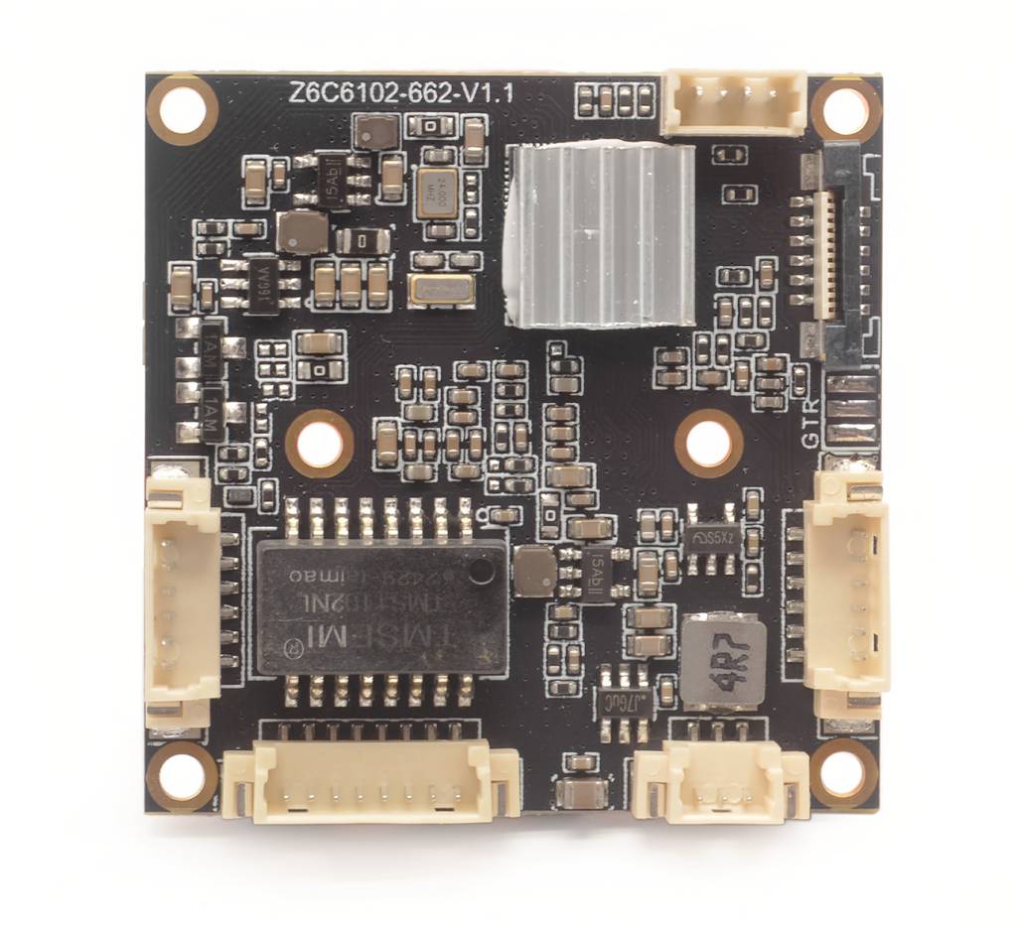

**Product features**

&H.265/H.264/MJPEG

&Video resolution：1920x1080/30fps

&Motor Lens: 2.8-12mm/6-22mm/5-50mm（optional）

&True WDR 120DB and AI denoise function

&Camera module built-in RTC battery

&support 2ch audio in&1ch audio out,1ch alarm in,1ch reset.

&TF card storage & alarm out &POE&WIFI are optional

&Support ONVIF Profile S

|  |  |  |  |
| --- | --- | --- | --- |
| Order Model: M662H16V62-L11 | | | |
| CPU Chips | | HI3516CV610-20S | |
| Flash | | 2Gbit SPI NAND Flash | |
| Module Size: | | | |
| One board | PCB size :38mm*38mm，  Lens holder size:34mm*34mm | | |
| Image | | | |
| CMOS Sensor | | SONY IMX662，1/2.8 Inch Progressive Scan CMOS sensor | |
| Wide dynamic range | | >120dB | |
| Motor lens | | 2.8-12mm/6-22mm/5-50mm（optional） | |
| Video resolution | | 1920*1080P/30fps | |
| Video coding | | H.265、H.264、 MJPEG | |
| Stream | | Main stream：1920*1080 1280*720 1-30fps（Optional 60fps） | |
| Sub stream：1280*720 704*576 352*288 1-30fps（Optional 60fps） | |
| Video Bit rate | | 16kbps~20Mbps，CBR/VBR | |
| S/N Ratio | | ≥58dB | |
| Min Illumination | | Color 0.005Lux@F1.2 | |
| Audio | | | |
| Audio Interface | | 1ch MIC In&Line In  1ch Line out (support voice intercom) | |
| Audio Format | | G.711A、G.711U | |
| Function | | | |
| AE | | support | |
| AGC | | support | |
| AWB | | support | |
| 3D | | support | |
| Privacy Mask | | Support 4 areas | |
| ROI | | support | |
| Off network record video | | support | |
| Motion detect | | Support 4detect areas | |
| Day&Night Switch | | Built-in intelligent algorithm to auto control IR CUT switch,color and white&night auto switch | |
| Video adjust | | Adjustable image contrast, brightness, saturation, sharpness and image mirroring, flipping, fog penetration, strong light suppression, backlight compensation, noise reduction level, digital wide dynamic, etc. | |
| Corridor mode | | support | |
| Remote manager | | System setting/Video stream management/Account management/Network management | |
| Alarm Detect | | E-mail alarm,PC client alarm,Motion detect alarm | |
| Function Interface | | 1ch Reset | |
| 2group TTL serial port,use to connect communicate device or PTZ control  (1 ch can be choose RS485 port) | |
| 1group I²C interface | |
| 1ch alarm in(standard),1ch alarm out（optional,need add one board） | |
| SD/TF card storage，max 1T（optional,need add one board） | |
| USB interface UVC protocol video out;  MJPEG /H264 coding， support 1080P、720P、VGA etc.(Optional) | |
| OSD | | OSD place ,color ,words can be config | |
| Network | | | |
| Ethernet Interface | | | 10M/100M RJ45 Network Interface |
| WIFI | | Support (optional) | |
| Video stream | | Dual stream（Three stream to be customized） | |
| Network protocol | | Support TCP/IP、UDP、RTP、RTSP、RTCP、RTMP、HTTP、DNS、DDNS、DHCP、NTP、PPPOE、SMTP、UPNP; | |
| ONVIF | | Support ONVIF ProfileS | |
| GB/T28181 | | Support | |
| CGI | | Support | |
| Environment | | | |
| Working temperature | | | -20°~+70° |
| Working humidity | | | 10%~90% |

**Module pin definition:**

