**5MP 60FPS Global Shutter Camera Module**

**IMX568+HI3519DV500 camera board(mono sensor and full sensor optional)**

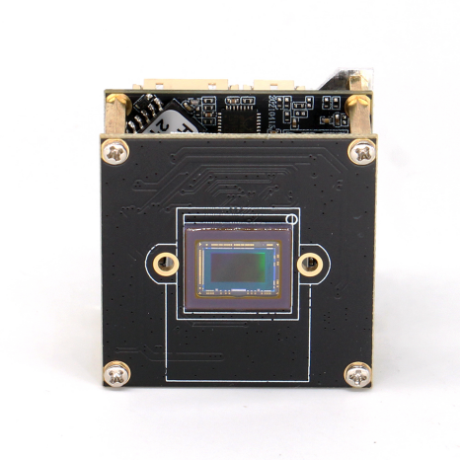

* Video Encoding:H.265/H.264/MJPEG
* Video resolution:2448*2048;
* Global shutter max to 5MP/60FPS
* Integrated neural network acceleration engine, computing power up to 2.5Tops INT8
* Dual ARM Cortex A55@1.2GHz processor, 32KB I-Cache, 32KB D-Cache ,256KB L3 cache
* USB3.0 video output,standard yuv protocol
* DC auto iris and CVBS can be optional ,need add one more expand board
* Default dual stream , main stream and sub stream
* Support AI super noise reduction, 3D noise reduction, 2D noise reduction, image edge enhancement, defogging, dynamic contrast enhancement, etc.
* Support automatic restart function after power failure/accidental failure;

**Datasheet:**

|  |  |  |
| --- | --- | --- |
| Order Model:M568H19D_L21_EN | | |
| System | | |
| CPU Model | | HI3519DV500 Dual ARM Cortex A55@1000MHz |
| CPU Ability | | 2.5 Tops INT8 |
| Flash | | 8GB EMMC |
| DDR | | **8Gbit DDR4 (2x 4Gbit)** |
| Image | | |
| Sensor Board | | SONY IMX568 1/1.8″Global Shutter Sensor |
| Video Resolution | | 2488*2048 /5MP |
| Video Compression | | H.265/H.264/MJPEG |
| Video Frame | | Main stream:2488*2048/2048*1520/ 1920*1080 1-60fps  Sub stream: 1280*720 /704*576/ 640*480 352*288 1-60fps |
| Lens | | Fix lens |
| Audio | | |
| Audio Interface | | 2ch audio in(1ch Line In &1ch MIC In)  1ch audio out,support voice intercom |
| Audio compression | | G.711A、G.711U |
| Image | | |
| AE | | support |
| AGC | | Support |
| AWB | | Support |
| 3D | | Support |
| Privacy Mask | | Up to set 4 Privacy mask area |
| Interesting area code | | Support |
| Off network record video | | Support |
| Motion detect | | Up to set 4 motion detect area |
| Day&Night Switch | | Built-in intelligent algorithm to auto control IR CUT switch,color and white&night auto switch |
| Video adjust | | Adjustable image contrast, brightness, saturation, sharpness and image mirroring, flipping, fog penetration, strong light suppression, backlight compensation, noise reduction level, digital wide dynamic, etc. |
| Corridor mode | | support |
| Remote manager | | System setting/Video stream management/Account management/Network management |
| Alarm Detect | | E-mail alarm,PC client alarm,Motion detect alarm |
| Function Interface | | 1CH Reset |
| 1CH RS485(Optional) |
| 1CH alarm in(standard),1CH alarm out（optional,need add one board） |
| SD/TF card storage，max 1T storage（optional,need add one board） |
| OSD | | OSD place ,color ,words can be config |
| Network | | |
| Ethernet Interface | | 1PCS RJ45 100M |
| Protocol | | TCP/IP、UDP、RTP、RTSP、RTCP、RTMP、HTTP、DNS、DDNS、DHCP、NTP、PPPOE、SMTP、UPNP; |
| ONVIF | | ONVIF Profile S |
| General Info. | | |
| PCB Size | CPU Board | 40*40mm(screw hole 34*34mm) |
| Sensor Board | 38*38mm(screw hole 34*34mm) |
| Lens holder Size | | 22mm |
| Power Supply | | DC12V(±10%) |
| Power Consumption | | TBD |
| Working temperature | | -30°~+70° |
| Working humidity | | 10%~90% |

